**PDR of electronics used in the rocketry –**

1. **7Semi BMP581 Barometric Pressure & Altitude Sensor Breakout**

The 7Semi BMP581 Barometric Pressure & Altitude Sensor Breakout provides ultra-precise pressure and temperature measurements with I2C and SPI connectivity, low power modes, and customizable performance for your sensing projects.

Exceptional Accuracy & Resolution:

* Pressure accuracy of ±0.5hPa across the sensing range.
* Resolution down to 1/64Pa, offering precise barometric and altitude data.

Low Power Consumption:

* Deep Standby mode consumes just 1.5µA, ideal for power-sensitive applications.
* Normal operating mode draws only 260µA during measurements.

Wide Sensing Range & High Data Rates:

* Pressure sensing range of 30 to 125kPa.
* Output data rates up to 622Hz for fast, real-time data processing.

Programmable Features for Customization:

* Configurable oversampling, FIFO buffer, and low pass filtering for tailored performance.
* Includes 6-bytes of non-volatile memory for user-specific data.

Cost- 796

1. **7Semi ICM-20948 9DoF IMU Breakout**

The 7Semi ICM-20948 9DoF IMU Breakout board offers state-of-the-art motion tracking capabilities with the world's lowest-power 9-axis MEMS MotionTracking device. Ideal for smartphones, tablets, and wearable sensors, this breakout board features a Digital Motion Processor (DMP) that enhances performance by offloading computation from sensors, ensuring optimal efficiency. With its compact design, versatile communication options, and easy integration with your projects, this IMU breakout board is a top choice for developers seeking precision and reliability.

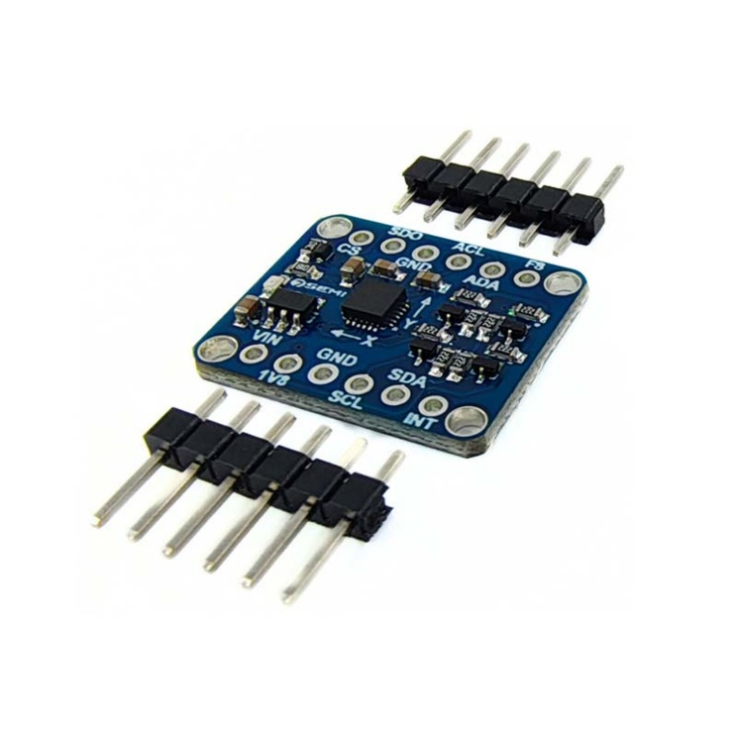

**Key Features:**

* **Comprehensive 9-Axis Motion Tracking:** Triple-axis gyroscope, accelerometer, and magnetometer with multiple programmable ranges.
* **Efficient Digital Motion Processor (DMP):** Offloads computation to ensure smooth and accurate motion tracking.
* **Versatile Communication Interfaces:** Supports I2C and SPI, with up to 7 MHz for SPI communication.
* **Wide Supply Voltage Range:** Operates efficiently between 1.95 V to 3.6 V.
* **Compact and User-Friendly Design:** Breakout board with 0.1"-spaced pins for easy breadboard use, and clearly labeled I2C/SPI pins for seamless integration.

Price- 860

1. **Zigbee XBee Module S2C**

Zigbee is a low-power wireless communication protocol, useful for real-time telemetry in the rocket. It can transmit sensor data such as altitude, temperature, and position back to a ground station. Its mesh network capability allows robust communication even in complex environments with obstacles.

<https://www.mouser.com/datasheet/2/111/ds_xbee-3-zigbee-3-1288823.pdf?srsltid=AfmBOor4w-LmduoaULaoqwj6U_CsMo1S1_4KRDPPBTNJZtvxSWnP_zEg> –datasheet

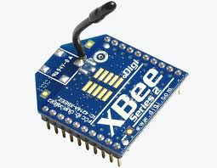

* **Frequency Range**: 2.4 GHz (global), 868 MHz (Europe), and 915 MHz (North America)
* **Data Rate**: Up to 250 kbps
* **Transmission Range**: Typically, up to 100 meters indoors (depends on the environment).up to 2 miles in outdoors.
* **Topology**: Supports star, tree, and mesh network configurations
* **Power Consumption**: Low power consumption, ideal for battery-operated devices
* **Protocol Standard**: IEEE 802.15.4

Price -2000

1. **Bharat Pi Node Wi-Fi with ESP32, SD Card**: Quad-core ARM Cortex-A72 (64-bit)

* **ESP32 Bit microcontroller – ESP32 Wroom**
* **Memory – 4MB**
* 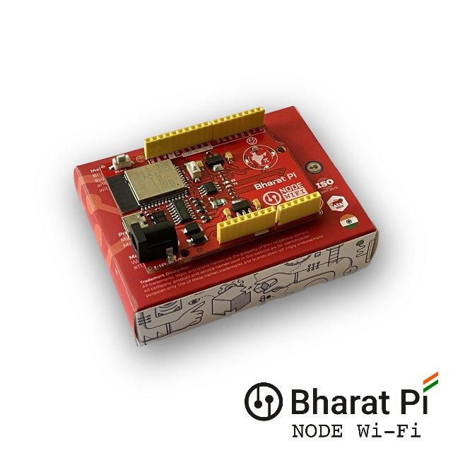**Storage – SD Card slot supports upto 64GB**
* **Reverse polarity protection – (Onboard fuse)**
* **USB Type-C connector**

Cost- 1003

1. **NavIC (Navigation with Indian Constellation)**

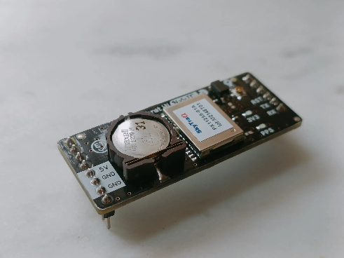NavIC is a satellite-based positioning system designed for regional navigation, offering high accuracy within India and nearby regions. It helps in tracking the rocket’s real-time GPS coordinates and ensuring precise positioning. It can also support recovery operations by locating the rocket after it lands.

<https://bharatpi.net/wp-content/uploads/2024/04/Bharat-Pi-NavIC-Module-Datasheet.pdf> - datasheet

* **Type**: Regional satellite navigation system by India
* **Coverage**: India and up to 1,500 km around the Indian mainland
* **Position Accuracy**: Typically 5-10 meters
* **Signal Frequency**: L5 (1.17645 GHz) and S-band (2.492028 GHz)
* **Applications**: Agriculture, disaster management, vehicle tracking, and navigation​.

Cost- 1770

1. **IRNSS/GPS/GLONASS L1 & L5 Antenna for NavIC GPS Tracker**

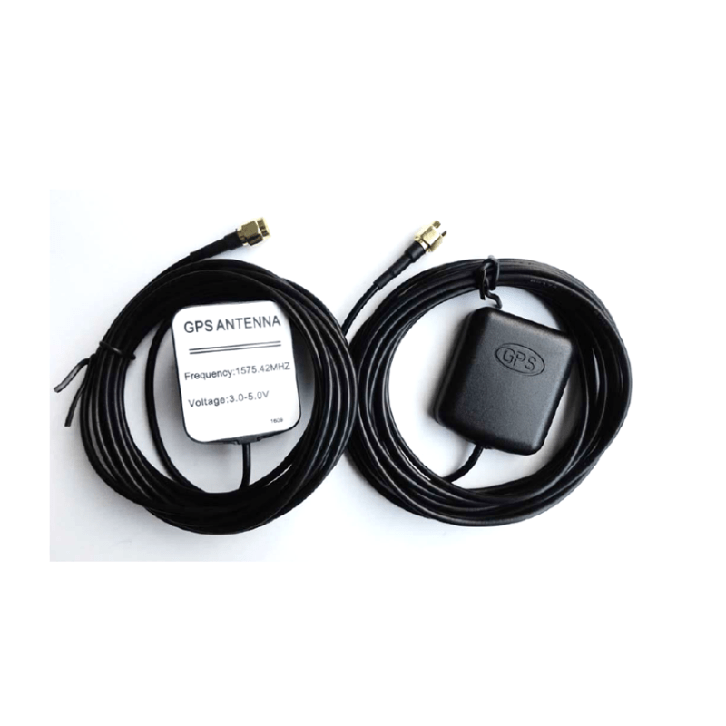

**IRNSS/GPS/GLONASS Antenna with RG174 Cable (L-3Mtr) and SMA (M) St. Connector. L1 + L5 band suitable for NavIC/IRNSS GPS trackers. Quick latching and magnetic mount for ease of use.**

Cost - 885

1. **Voltage Detection Sensor Module 25V**

The Voltage Detection Sensor Module 25V allows you to use the Analog input of a microcontroller to monitor voltages much higher than it capable of sensing.

* 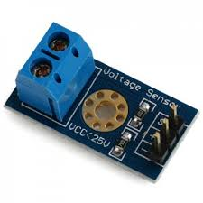**Voltage Detection Range (V):**  0.02445 to 25
* **Dimensions:** 28*14*13 MM
* **Weight:** 5 g

Cost - 17

1. **Temperature Sensor**

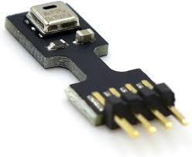The AHT25 Integrated temperature and humidity sensor is equipped with a newly designed ASIC dedicated chip, an improved MEMS semiconductor capacitive humidity sensor element and a standard temperature sensor element, and its performance has reached the industry’s advanced level. The improved new generation temperature and humidity sensor AHT25 has a more stable performance in harsh environments and can maintain good accuracy in a larger measurement range.

* Digital output, I²C interface
* Quick response and strong anti-interference ability
* Relative humidity and temperature output

Cost - 135

1. **Battery for ignition.**

We are planning to ignite the fuel with carbon lid and passing of electricity through it which release high amounts of temperature through temperature.